Data S1. Identification of M. truncatula isoflavonoids.
Based on the PCA analysis presented in Figure 2f, a subset of 124 m/z peaks with a higher abundance in the EMA1^{OE} lines were considered as important contributors to the difference between the EMA1^{OE} and the control lines. Peak grouping (based on retention time) revealed that 61 of those peaks were attributed to only two metabolites, eluting at 14.68 and 16.59 min, respectively, with a dramatically increased abundance in the EMA1^{OE} lines. Upon inspection of the LC-ESI-FT-ICR-MS chromatograms, these peaks appear visibly increased in the EMA1^{OE} lines (Figure 1a of Data S1). The MS scan of the first peak, eluting at 14.68 min, contained a [2M-H]⁻ dimer ion with an accurate mass of 1031.24517 Da. A minor [M-H]⁻ peak appeared at m/z 515.12026, corresponding to the brutoformula C₂₅H₂₄O₁₂ (δppm = 1.477). An additional in-source fragment appeared at m/z 267.06640 (C₁₆H₁₂O₄; δppm = 0.441; Figure 1b of Data S1). Similarly, the peak eluting at 16.59 min has an [M-H]⁻ ion at m/z 517.13644 (C₂₅H₂₆O₁₂; δppm = 2.496) and an in-source fragment at m/z 269.08229 (C₁₆H₁₄O₄; δppm = 1.330; Figure 1b of Data S1).
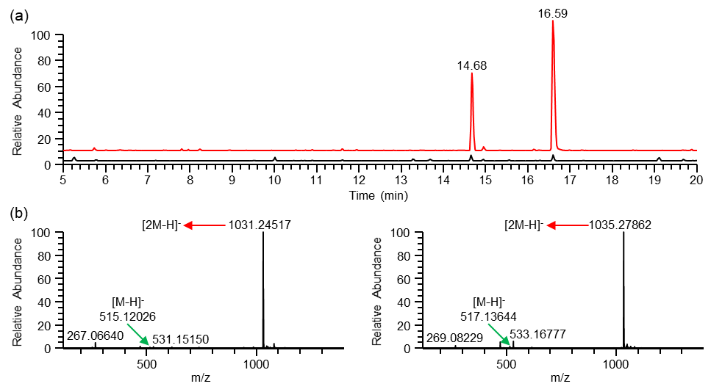
Figure 1. LC-ESI-FT-ICR-MS analysis of CTR and EMA1^{OE} lines. (a) LC-ESI-FT-ICR-MS chromatograms of an extract from CTR (black) and EMA1^{OE} (red) roots. The peaks at t_{R} 14.68 and 16.59 min are dramatically increased in the EMA1^{OE} lines. (b) MS scans of the peaks at t_{R} 14.68 (left) and 16.59 (right) min.
The metabolite eluting at 14.68 was further elucidated based on its MS^{n} fragmentation. The MS² fragmentation of the dimer at m/z 1031.25 led to major daughter ions at m/z 987, 943, 781, 739, 515, and 471 (Figure 2a of Data S1), with the daughter ion at m/z 515 corresponding to the [M-H]⁻ ion. The daughter ion at m/z 471 results from a neutral loss of 44 Da from the [M-H]⁻ ion, corresponding to the loss of a CO₂ moiety. Indeed, the ion at m/z 471 also occurs as an in-source fragment of the unknown metabolite and has an accurate mass of 471.13036 Da (Figure 2b of Data S1), corresponding to the brutoformula C₂₄H₂₄O₁₀ (δppm = 1.464), which again indicates the loss of a CO₂ moiety from the unknown metabolite with a calculated brutoformula of C₂₅H₂₄O₁₂. Fragmentation of the in-source fragment ion at m/z 471 led to a single daughter ion at m/z 267 (Figure 2c of Data S1), which corresponds to the in-source fragment ion with a calculated brutoformula of C₁₆H₁₂O₄, implying a neutral loss of 204 Da or C₈H₁₂O₆, corresponding to the loss of a hexose (162 Da; C₆H₁₀O₅) and a ketene (42 Da; C₂H₂O). The loss of a CO₂ and ketene moiety indicates the unknown metabolite likely corresponds to a malonylated compound, which further contains a hexose moiety and an aglycone with a calculated brutoformula of C₁₆H₁₂O₄. Aglycones with this molecular formula include the isoflavone formononetin (Farag et al., 2007). Indeed, the MS² fragmentation of the aglycone at m/z 267 led to a single daughter ion at m/z 252 (Figure 2d of Data S1), indicating a loss of a methyl radical, typical of an O-methylated metabolite like formononetin. Furthermore, the MS³ fragmentation of the m/z 252 radical ion of the aglycone (Figure 2e of Data S1) corresponds well with the reported MS³ fragmentation of formononetin (Kang et al., 2007). Taken together, the metabolite eluting at 14.68 min likely corresponds to formononetin glucoside malate (FGM), a metabolite known to accumulate in M. truncatula (Farag et al., 2007).
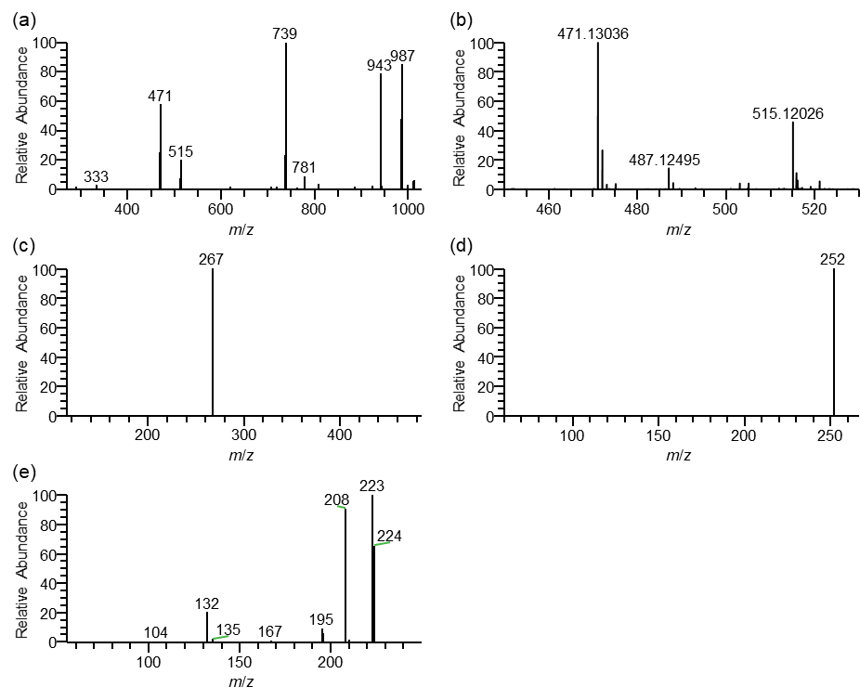
Figure 2. Identification of FGM (formononetin glucoside malate) by MS^{n} fragmentation. (a) MS² fragmentation of the dimer at m/z 1031.25. (b) FT-MS scan revealing the accurate mass of the in-source fragment ion at m/z 471. (c) MS² fragmentation of the in-source fragment ion at m/z 471. (d) MS² fragmentation of the aglycone at m/z 267. (e) MS³ fragmentation of the m/z 252 radical ion of the aglycone at m/z 267.
Similarly, the metabolite eluting at 16.59 min was further elucidated based on its MS^{n} fragmentation. MS² fragmentation of the dimer at m/z 1035.28 led to major daughter ions at m/z 991, 947, 517, and 473 (Figure 3a of Data S1), with the daughter ion at m/z 517 corresponding to the [M-H]⁻ ion. The daughter ion at m/z 473 results from a neutral loss of 44 Da from the [M-H]⁻ ion, corresponding to the loss of a CO₂ moiety. The ion at m/z 473 also occurs as an in-source fragment of the unknown metabolite and has an accurate mass of 473.14631 Da (Figure 3b of Data S1), corresponding to the brutoformula C₂₄H₂₆O₁₀ (δppm = 2.092), which again indicates the loss of a CO₂ moiety from the unknown metabolite with an accurate mass of 517.13620 Da (Figure 3b of Data S1) and a calculated brutoformula of C₂₅H₂₆O₁₂ (δppm = 2.032). Fragmentation of the in-source fragment ion at m/z 473 led to a single daughter ion at m/z 269 (Figure 3c of Data S1). The loss of a CO₂ moiety and a neutral loss of 204 Da is similar to the losses observed for FGM, implying a similar glucoside malate, but a different aglycone for this metabolite. The aglycone occurs as an in-source fragment ion with an accurate mass of 269.08229 (Figure 1b of Data S1) and a calculated brutoformula of C₁₆H₁₄O₄ (δppm = 1.330). Aglycones with this molecular formula include the pterocarpan medicarpin, the isoflavone genistein and the flavanone naringenin (Farag et al., 2007). The MS³ fragmentation of the daughter ion at m/z 269 leads to a single granddaughter ion at m/z 254 (Figure 3d of Data S1), indicating the aglycone is an O-methylated metabolite like medicarpin. Taken together, the metabolite eluting at 16.59 min likely corresponds to medicarpin glucoside malate (MGM), also a compound known to accumulate in M. truncatula (Farag et al., 2007).
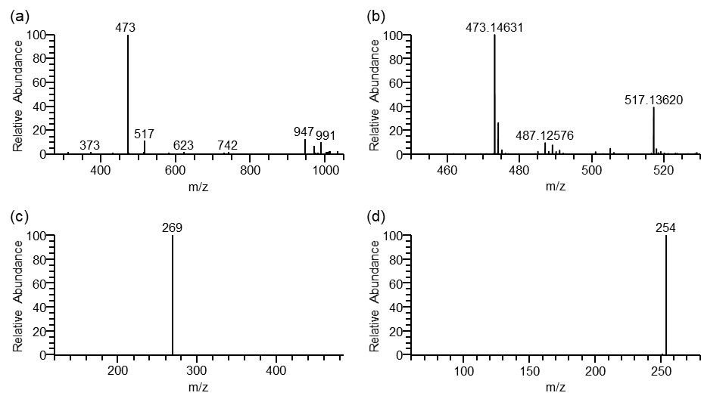
Figure 3. Identification of MGM (medicarpin glucoside malate) by MS^{n} fragmentation. (a) MS² fragmentation of the dimer at m/z 1035.28. (b) FT-MS scan revealing the accurate mass of the in-source fragment ion at m/z 473. (c) MS² fragmentation of the in-source fragment ion at m/z 473. (d) MS³ fragmentation of the daughter ion at m/z 269.
Next to the 61 m/z peaks derived from FGM and MGM, 63 additional m/z peaks with a higher abundance in the EMA1^{OE} lines were considered as important contributors to the difference between the EMA1^{OE} and the control lines. Peak grouping revealed several lower abundant metabolites with at least two m/z peaks that significantly contribute to the difference between the EMA1^{OE} and the control lines. One of these peaks, eluting at 14.92 min, has a [2M-H]⁻ dimer ion with an accurate mass of 1091.26436 Da (Figure 4a,b of Data S1). A minor [M-H]⁻ peak appeared at m/z 545.13014, corresponding to the brutoformula C₂₆H₂₆O₁₃ (δppm = 0.140). Like for FGM and MGM, the metabolite is a glucoside malate, but with an aglycone in-source fragment ion with an accurate mass of 297.07681 (C₁₇H₁₄O₅; δppm = -0.124; Figure 4b of Data S1). Aglycones with this molecular formula include the isoflavone afrormosin (Farag et al., 2007). Indeed, the MS² fragmentation of this aglycone (Figure 4c of Data S1) indicates the presence of an O-methyl group, and the loss of a second methyl radical in the MS³ fragmentation of the aglycone (282 267; Figure 4d of Data S1) implies the presence of a second O-methyl group, a fragmentation pattern that fits well with afrormosin as aglycone. Taken together, the metabolite eluting at 14.92 min likely corresponds to afrormosin glucoside malate (AGM), another compound known to accumulate in M. truncatula (Farag et al., 2007).
Other m/z peaks with an apparent higher abundance in the EMA1^{OE} lines were not identified as they either were the result of integration issues or too low abundant for MS^{n} fragmentation and tentative identification.
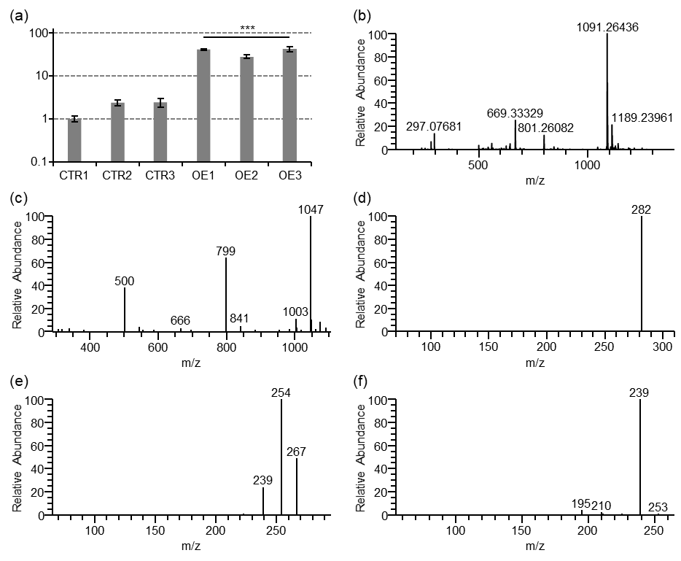
Figure 4. Identification of AGM (afrormosin glucoside malate) by MS^{n} fragmentation. (a) Normalized ion current of AGM in three control (CTR) and three EMA1^{OE} (OE) lines showing higher abundance of AGM in the EMA1^{OE} lines. Error bars indicate SEM; n = 5 technical replicates. Statistical significance was determined by a Student’s t-test with Welch correction (***p<0.001) (b) FT-MS scan of the AGM peak eluting at 14.92 min. (c) MS² fragmentation of the dimer at m/z 1091.26. (d) MS² fragmentation of the in-source fragment at m/z 297.08. (e) MS³ fragmentation of the daughter ion at m/z 282. (f) MS⁴ fragmentation of the granddaughter ion at m/z 254.
REFERENCES
Farag, M.A., Huhman, D.V., Lei, Z. and Sumner, L.W. (2007) Metabolic profiling and systematic identification of flavonoids and isoflavonoids in roots and cell suspension cultures of Medicago truncatula using HPLC-UV-ESI-MS and GC-MS. Phytochemistry 68, 342-354.
Kang, J., Hick, L.A. and Price, W.E. (2007) A fragmentation study of isoflavones in negative electrospray ionization by MS^{n} ion trap mass spectrometry and triple quadrupole mass spectrometry. Rapid Commun. Mass Spectrom. 21, 857-868.

