APPLICATION OF CFD TO TRANSIENT FLOWS IN COMPLIANT LUNGS

M Walters¹, A K Wells¹, I P Jones¹, I S Hamill¹, B Veeckmans², W Vos³, C Van Holsbeke³, C Fetita^{4,5}, C Lefevre⁴.
¹ANSYS UK Ltd., ²Materialise NV, ³FluidDA NV, ⁴Institut Telecom, ⁵MAP5 - CNRS UMR 8145

Email for correspondence, martin.walters@ansys.com

Abstract. Patient-specific simulation of flows in lungs is now straightforward, by segmenting scans from CT and other imaging techniques, creating surface meshes of the lower airways, and using these as the geometries for a computational fluid dynamics (CFD) simulation. The resulting flows have been used to aid drug deposition studies and the treatment of asthma and COPD. The Airprom project is a European collaborative project aiming to predict the natural history of airways diseases through patient-specific multi-scale computational models and to investigate if models can predict the magnitude of the effect of a theoretical, new or current therapy required within an individual to translate into an important clinical outcome.
These computational models have not realised their full clinical potential, as they have not been extensively validated in large cohorts of well characterised patients. Consequently, their ability to predict future outcomes has not been fully defined. One aspect of Airprom is to automate the simulation of the flows in the lower conducting airways, the intrapulmonary airways, from the trachea to about the sixth branch, taking realistic conditions into account. This will allow the methodology to be applied to a large number of patients and hence help to validate the outcomes of the simulations and its role in predicting the natural history and response to therapy in airway disease.
This paper considers one aspect of this work, focussing on the motion of the lungs during the breathing cycle, and how this affects the resulting flows and airway resistances, as well as the effect of compliance in the lung geometry. The approach adopted is also capable of being used on medical applications, where the geometry is highly dynamic and defined from medical images.

Keywords: pulmonary airways, 3D segmentation, computational fluid dynamics simulation, transient flows, compliant lungs

1. Description of purpose
Patient-specific simulation of flows in lungs is now straightforward, by segmenting scans from CT and other imaging techniques, creating surface meshes of the lower airways, and using these as the geometries for a CFD simulation. The resulting flows have been used to aid drug deposition studies [1] and the treatment of asthma and COPD, for example [2], [3]. The Airprom project [4] is a European collaborative project aiming to predict the natural history of airways diseases through patient-specific multi-scale computational models and to investigate if models can predict the magnitude of the effect of a theoretical, new or current therapy required within an individual to translate into an important clinical outcome.
These computational models have not realised their full clinical potential, as they have not been extensively validated in large cohorts of well characterised patients. Consequently, their ability to predict future outcomes has not been fully defined. One aspect of Airprom is to automate the simulation of the flows in the lower conducting airways, the intrapulmonary airways, from the trachea to about the sixth branch, taking realistic conditions into account. This will allow the methodology to be applied to a large number of patients and hence help to validate the outcomes of the simulations and its role in predicting the natural history and response to therapy in airway disease.
This paper considers one aspect of this work, focussing on the motion of the lungs during the breathing cycle, and how this affects the resulting flows and airway resistances, as well as the effect of compliance in the lung geometry. The approach adopted is also capable of being used on medical applications, where the geometry is highly dynamic and defined from medical images.
2. Materials and methods
Limited data is available to define the geometry of the airways during the breathing cycle, in part because of the need to limit radiation doses. The simulations therefore use the scans at Total Lung Capacity (TLC) and Functional Residual Capacity (FRC), to define the location of the airways at intermediate times during the breathing cycle.
Segmentation
The segmentation is carried out using either the Mimics Software [5] from Materialise or the Airways software [6] from Institut Telecom. These provide labelled cleaned-up faceted surface meshes in the ANSYS .msh format. An extension of the Ikeda naming convention [7] is used to define the airway branches, and to enable the airway peripheral branches to be identified consistently. This format can be used directly by the ANSYS geometry and meshing tools, to create the volume meshes to be used by the CFD simulations. In addition to the segmented surfaces at TLC and FRC, a one-dimensional representation of the airways, a ‘skeleton’, is created at FRC and TLC. These skeletons contain the coordinates of the centreline of the airway tree, and a representation of the radius of the airway. These are used as the basis for the creation of consistent volume meshes.
Geometry Registration
The registration process is aimed at determining geometrical transformations to match the geometry at different times. This enables the lung geometry to be constructed at different times in the breathing cycle. This is non-trivial, as the size of the facets within the geometry is comparable to the diameter of the airways in the lower branches of the lungs. A simple approach is adopted here, to enable a fast method based on the use of the skeletons as a template representation of the airways. A consistent conceptual solid model of the lungs is created based upon intersecting cylinders, using the skeleton parameters at TLC and FRC to provide the extent and diameter of the cones. Figure 1 illustrates this process schematically, showing the local cylindrical coordinate system used within each cylinder. From this it is possible to map a point in a surface mesh between TLC and FRC. Using these relationships, a single unstructured mesh topology can then be created which morphs between the two ends of the breathing cycle. This can then be used in a straightforward manner in the CFD simulation software. This process is illustrated using a case study for an asthmatic patient case, patient A017 from the Airprom study. Figure 2 shows images of the surface meshes from the segmentation with the consistent skeletons superimposed.

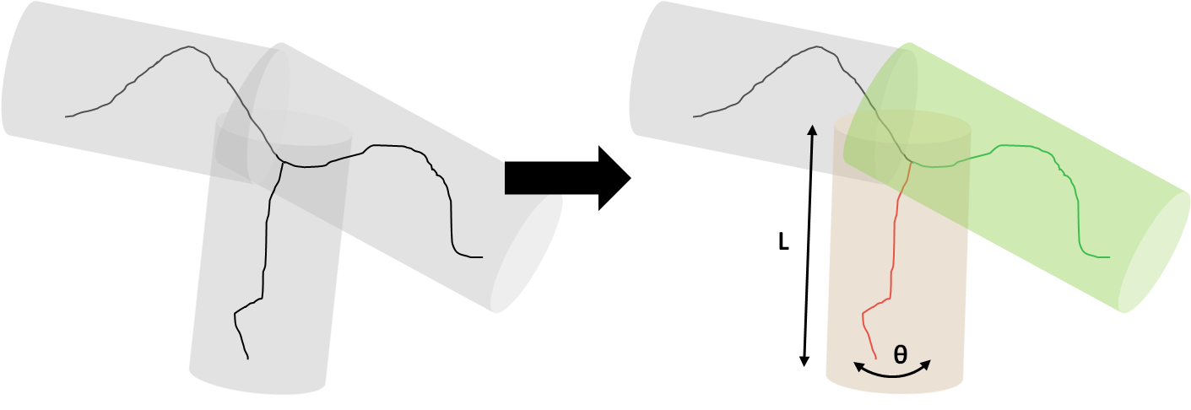
Figure 1: Schematic Representation of the Registration Process.

3. Results and discussion
Using the standard Arbitrary Lagrangian Eulerian (ALE) approach within the ANSYS CFD software a single parametrised mesh is created which morphs between FRC and TLC within the breathing cycle. In the absence of other information, for this case study, a sinusoidal motion between these two extremes is imposed, although it would be straightforward to impose some other motion.
The results show a number of interesting features with large changes in the first few branches:
- From the back view, it is clear that the trachea does not remain cylindrical and has a well-developed concave region at FRC.
- The trachea develops wrinkles, and there is a significant curvature along the trachea at FRC, and ‘wrinkles’ lengthwise along its extent. This is consistent with the airways being compressed from below by the movement of the diaphragm.
The presentation will include the results from further case studies, including both normal and asthmatic patients, to explore the differences in the results, especially the changes in resistance during the breathing cycle. The implications for drug deposition in the lungs will also be discussed.
4. New or breakthrough work to be presented
This paper studies the motion of the lungs during the breathing cycle, and how this affects the resulting flows and airway resistances, as well as the effect of compliance in the lung geometry.
5. Conclusion
Predicting disease evolution or therapy outcomes in asthma and COPD via CFD simulations of the airflow parameters requires taking into account the dynamic deformation of the airway tree during the respiratory cycle.
6. Was this work submitted elsewhere?
No.
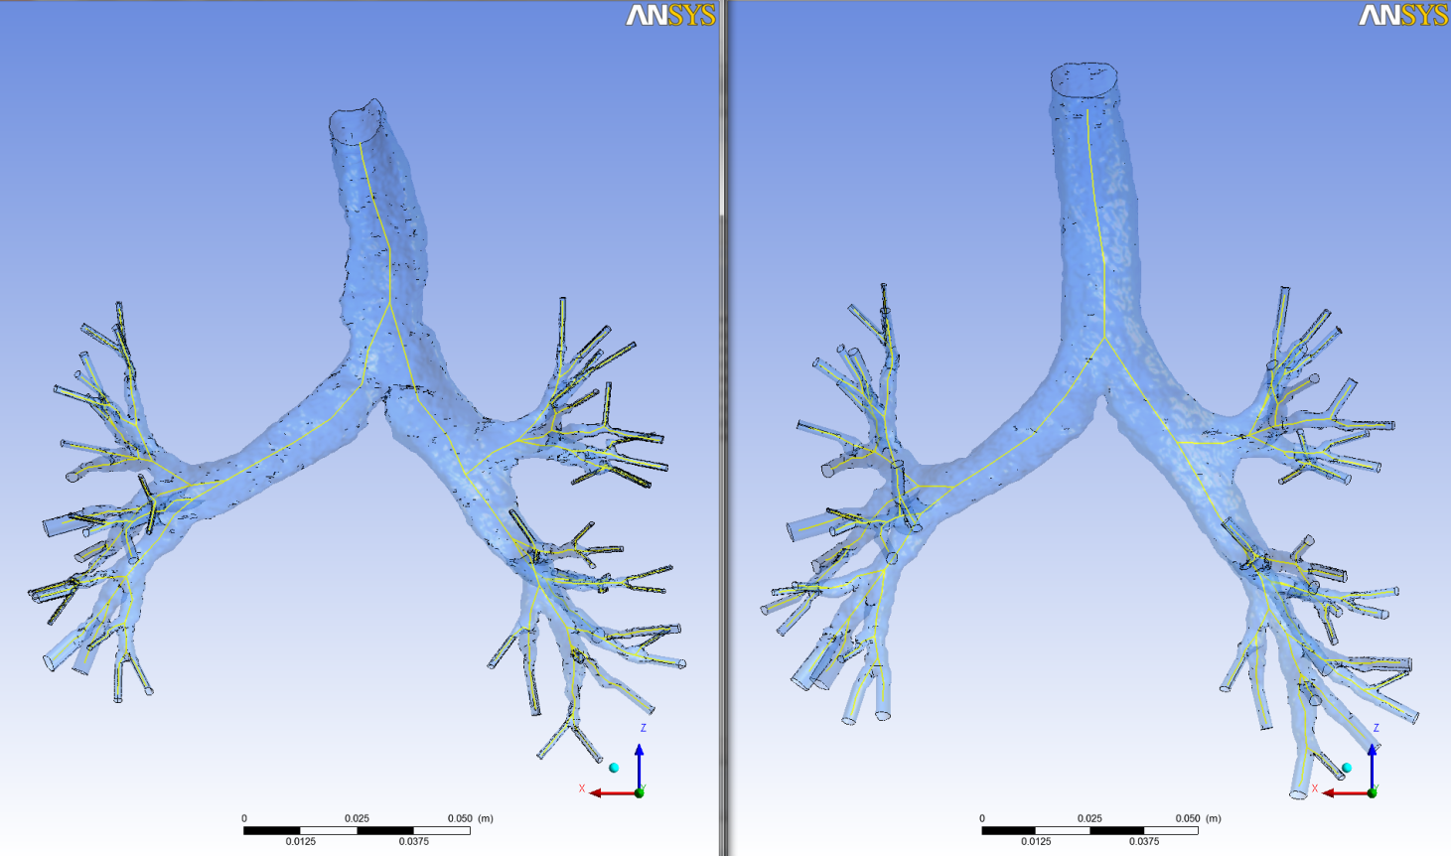
Figure 2: Lung Surface Meshes and Ordered Skeletons, left FRC, right TLC.

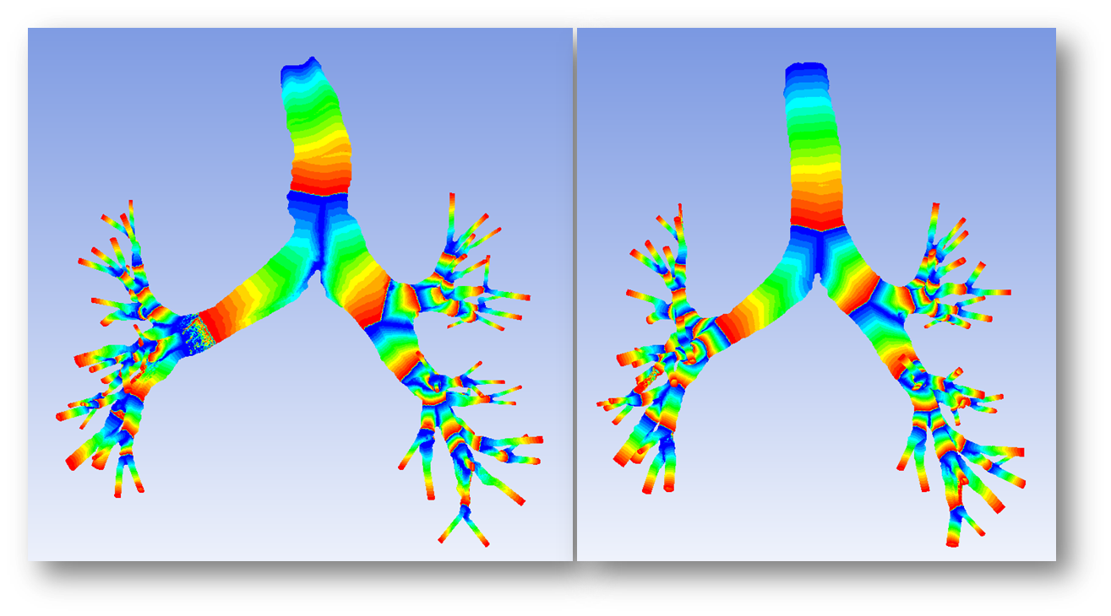
Figure 3: Length Ratio for each 'cylinder’ at FRC (left image) and TLC (right image)

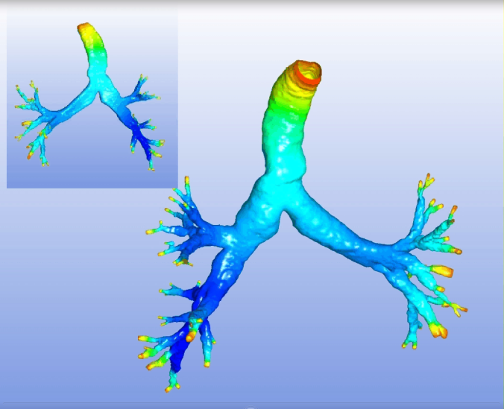 | 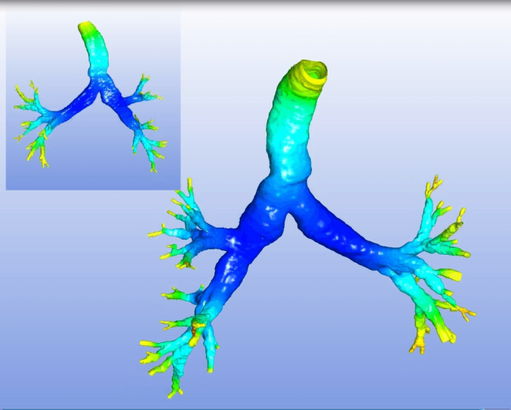
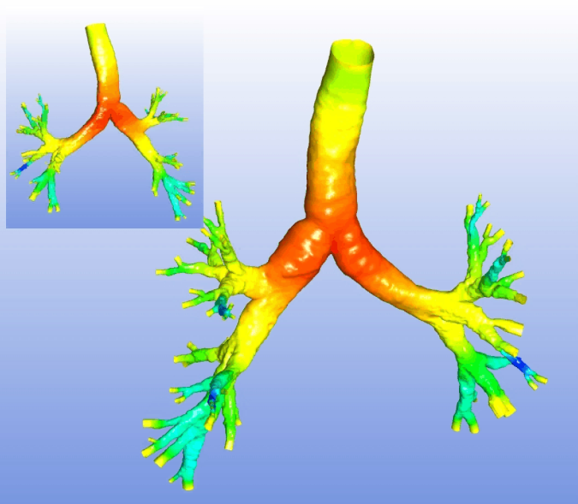 | 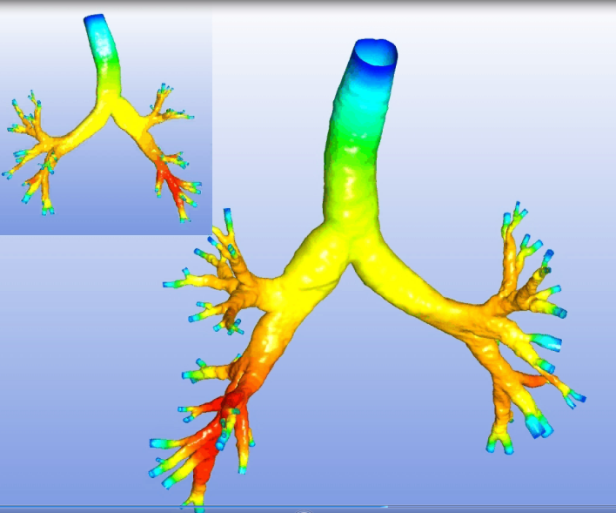
Figure 4: Snapshots from an animation of the motion of the airways, colour coded by the local pressure. Top Left, FRC, Bottom right, TLC, with two intermediate snapshots during the breathing cycle. The inset pictures are views of the geometry from the back.

ACKNOWLDEGEMENTS
On behalf of the AirPROM consortium. The research leading to these results has received funding from the European Union Seventh Framework Programme FP7/2007-2013 under grant agreement no 270194.

REFERENCES
- B Brook et al, Modelling of Air Flow in the Human Airways Using Computational Fluid Dynamics and Dynamic Hyperpolarized 3HE MRI. http://cds.ismrm.org/ismrm-2004/Files/001680.pdf, 2004.
- W Vos et al. Novel Functional Imaging Of Changes In Small Airways Of Patients Treated With Extrafine Beclomethasone/Formoterol, , Respiration 2013 Double blind, placebo controlled crossover study in COPD patients to assess the acute effect of budesonide/formoterol using multi-slice CT and lung function tests. De Backer LA, Vos W, De Backer J, Van Holsbeke C, Vinchurkar S, De Backer W., European Respiratory Journal 2012;40:298-305.
- LA De Backer et al. Double blind, placebo controlled crossover study in COPD patients to assess the acute effect of budesonide/formoterol using multi-slice CT and lung function tests. European Respiratory Journal 2012;40:298-305
- The Airprom Project, http://www.airprom.european-lung-foundation.org/
- The Mimics Software, http://biomedical.materialise.com/mimics
- C Fetita et al., A morphological-aggregative approach for 3D segmentation of pulmonary airways from generic MSCT acquisitions, Proc. of Second International Workshop on Pulmonary Image Analysis - MICCAI'09, United Kingdom, 2009, pp. 215-226.
- See for example, Netter, F.H., 1980. The CIBA collection of medical illustrations, vol. 7. W B CIBA, 1980.

