Heat recovery ventilation operation traded off against natural and simple exhaust ventilation in Europe by primary energy factor, carbon dioxide emission, household consumer price and exergy.

J. Laverge* & A. Janssens
Ghent University, Department of Architecture and Urban Planning,
Jozef Plateaustraat 22, Gent, Belgium

*Corresponding Author:
tel +3292643749 / fax +3292644185
email jelle.laverge@ugent.be

Abstract
Indoor air pollution has a negative impact on human health, comfort and productivity. Emissions, however, are often related to essential functions of the indoor environment and cannot be eliminated with source control. Ventilation is then used to dilute these pollutants to acceptable concentrations.
Due to recent crises in the energy markets and the subsequent quest for higher efficiency in energy use, heat recovery ventilation has gained capstone status in sustainable building concepts. However, along with a reduction of ventilation heat loss, operating a heat recovery unit increases the pressure drop and fan power consumption in the system. These aspects are rarely traded off against each other and even more scarcely for a broad range of operating conditions. This paper addresses this trade-off based on primary energy, carbon dioxide emission, household consumer energy price and exergy frameworks for the different climates in Europe.
The results presented here demonstrate that, for the moderate climate region of middle Europe, natural ventilation, simple exhaust mechanical ventilation and heat recovery ventilation have no clear advantage over each other as far as operating energy is concerned. Realistically low specific fan power will make heat recovery ventilation advantageous in virtually all tested conditions.

Keywords
ventilation; heat recovery; primary energy; carbon dioxide emission; operating energy cost; exergy; climate; degree days;

Introduction
Over the last decades, researchers from a broad range of fields have abundantly demonstrated the impact of indoor air pollution on human health [1], comfort [2-4] and productivity [5, 6]. As people spend about 90% of the time indoors [7, 8], the minimization of these effects is essential. The issue has been prioritized by WHO [9]. Although source control is the most effective and straightforward way to reduce exposure to harmful pollutants, some emissions are related to the very function of the building, such as housing the occupants in residences. The sources related to these essential functions can’t be eliminated. Therefore, the pollutant concentrations are diluted by ventilation.
With continuing stress on energy prices and overwhelming scientific consensus about the climate impact of fossil fuel depletion [10], the last decades also brought about a focus on energy efficiency. In the EU, space heating accounts for about 26% of all final energy consumption [11, 12]. Since infiltration, adventitious and intended ventilation combined represent about 50% of the total heat loss in well insulated buildings, this focus has resulted in an improved airtightness of newly built construction and an increased implementation of controlled ventilation flow rates.
Heat recovery ventilation has, after its successful introduction in the Scandinavian market, gradually attained a capstone status among energy efficient ventilation strategies. Due to its competitive price setting as well as due to reports in popular media and scientific literature about possible health risks associated with heat recovery systems [13] however, simple mechanical exhaust ventilation dominates the residential ventilation market [14, 15] in the moderate climate zone of western Europe, such as the Netherlands, France, the UK and Belgium, while the Southern regions of Europe tend to rely on natural ventilation. Since optimization studies [16] have demonstrated that the optimal performance of appropriately sized balanced mechanical ventilation without heat recovery, simple exhaust mechanical ventilation and natural ventilation is equal with regard to both heat loss and mean exposure to pollutants, no a priori towards one of them can be assumed.
Balanced mechanical ventilation, on the other hand, has the advantage over the other system approaches that air to air heat exchangers can be added to the concept to achieve heat recovery between supply and exhaust air, thus considerably reducing ventilation heat losses. Nevertheless heat recovery ventilation operation is faced with a trade-off: an increased pressure drop due to the narrow passages in the heat exchanger unit for heat recovery ventilation companions the decrease in heat loss due to that same heat recovery. The increased pressure drop will in turn lead to a higher electric energy use for the fan, while the reduced heat loss will lower the space heating load. The balance between both is, beside by system characteristics, strongly affected by climate and by the conversion factor used to compare electricity consumption to fossil fuel consumption. Simple exhaust ventilation has the disadvantage that no broadly available technology allows for heat recovery on it, while it still needs electricity for fan operation. Nonetheless, it provides more stable flow conditions than natural ventilation and some of the energy in the exhaust air can be recovered by the implementation of heat pump technology for domestic hot water production or for low temperature heating systems [17-19].
Although numerous papers discuss the performance of heat recovery ventilation [20, 21], the sensitivity of this performance to variations in climatic conditions [22-27] or the impact of simple exhaust mechanical ventilation and natural ventilation on the indoor environment [28, 29], they are rarely traded off against each other. Dodoo [30], however, presented an analysis of their respective merits in a very specific context with district heating. Nevertheless, the number of climatic conditions considered is always rather limited.
Therefore, in this paper, we investigate the tradeoff between heat recovery and increased electricity load for the operating phase of heat recovery ventilation for the different climates in Europe by using a set of possible conversion factors for electricity, based on primary energy, carbon dioxide emission, operating cost and exergy frameworks respectively. In the first section of the paper, the tradeoff is studied using fixed assumptions for the relevant system characteristics and boundary conditions. The sensitivity of the results with regard to these assumptions is then treated in the discussion section.

Methods
The frameworks used to trade off heat loss and electricity consumption all have their specific limitations. When considering carbon dioxide emissions, for example, nuclear power is a positive contributor to emission reductions. This, however, completely neglects all other considerations regarding safety and waste management that are associated with that particular technology. Using 4 different frameworks allows to grasp more than one of these facets, but is still incomplete and should be supplemented with additional information.
The results presented only consider the operating energy under different trade-off conditions. It has to be stressed that the method proposed is not suited for the prediction of actual performance of a specific implementation of a system, but is merely focused on demonstrating the distribution and variability of the potential for heat recovery ventilation. The potentials, demonstrated in the figures shown in the results section, are valuable resources for fixing stimulus policies and during conceptual design phases. A more complete feasibility assessment for a specific project should be based on precise system characteristics and climate data and should include investment costs, building specific elements such as acoustic nuisance, draft risk or the need to filter contaminated outdoor air and additional operating costs such as maintenance and component replacement (eg. fans and filters!).
The assessment of heat recovery ventilation made in this paper only takes in to account the intended ventilation. The ventilation systems are all assumed to run at a constant rate, all year long. This is a valid assumption since, although occupants tend to open windows during summer [31], thus increasing the total air flow rate, the system is rarely shut down. The ability to shut the system down is even forbidden in some ventilation standards [32]. For all of the coefficients used, averaged values should be handled with care.

2.1 Climate and recovered heat
To characterize the different climate conditions, the heating degree day [33] data from Eurostat [34] is used (Fig 1.). The data was averaged over a 10 year period from 2000-2009.
This data conforms to the NUTS 2 level as defined by Eurostat [35] which corresponds to a subnational, regional scale for EU Member States, Norway, Turkey, Croatia, Switzerland, Liechtenstein and Iceland. For some regions the data is available on NUTS 3 (city) scale. The data was used in its finest geographical form available.
In accordance with the Eurostat definition of heating degree days (HDD) [36], which assumes a heating threshold of 15 °C and an indoor temperature of 18 °C, the number of heating degree days for any given day is defined as 18 °C minus the daily mean temperature, whenever that daily mean temperature is below 15 °C. The daily mean temperature is defined as the mathematical average of the minimum and maximum temperature of that day. Based on this definition, the average number of HDD for the EU is 3000. The distribution of HDD within the EU is shown in Fig. 1.
Fig. 1. HDD in the EU [34]
The total heat recovered annually by a heat recovery unit (HRU) is calculated from the heat content of the ventilation air:

$$Q_{HR}= \int_{a}{ρ∙c∙ε∙\dot{\dot{g}\left(t\right)∙}∆T\left(t\right) dt}$$
With:
Q_{HR} total annual heat recovered [J]
r density [kg/m³]
c specific heat capacity [j/kgK]
e effectiveness of heat recovery unit [-]
ġ flow rate [m³/s]
t time [s]
ΔT indoor/outdoor temperature difference [K]

Assuming density, specific heat capacity and effectiveness to be constant over the whole heating season and assuming 1224 J/m³K to be the volumetric heat capacity of air, normalized per m³/h, this can be transformed to:

$$q_{HR}= 24 ∙ 1224 ∙ε∙HDD= 29376∙ε∙HDD$$

With:
q_{HR} total annual heat recovered per m³/h [Jh/m³]
e effectiveness of heat recovery unit [-]
HDD number of heating degree days [Kday]

Balanced heat recovery ventilation can only recover heat from the mechanically supplied/exhausted fraction of the total outdoor air exchange rate. On the other hand, it also only uses electrical energy for that particular fraction. Therefore, infiltration is not accounted for in the method presented here. Multi-zone simulation results [37] demonstrate that the type of ventilation system (balanced mechanical, mechanical exhaust or natural) has only a minor effect on the total infiltration. Although exhaust ventilation depressurizes the building, thus potentially reducing infiltration, the sizing of trickle ventilators usually decreases this depressurization below the prevailing wind and buoyancy pressure differentials, largely canceling this effect [38]. Only in the rare cases where an extreme airtightness level and small trickle ventilator sizing are combined the consequent reduction of infiltration due to the mechanical exhaust ventilation should be taken into account. Again this falls out of the scope of this paper.

2.2 Fan power
The (increase in) electric load for fan operation in the heat recovery ventilation system is highly dependent on fan and ducting characteristics. In addition, fan power will typically increase with higher HRU effectiveness. Nevertheless, the use of specific fan power (SFP) allows for a straightforward approach to it. The European standard EN 13779 [39] specifies SFP 3-4, 750-2000 J/m³ per fan, as default values for heat recovery systems and SFP 2, 500-750 J/m³, for simple exhaust systems. For the results presented below, the boundary between SFP 3 and SFP 4, 1250 J/m³ per fan, is used as a reference specific fan power for heat recovery systems, while the upper limit of SFP 2, 750 J/m³, is used for simple exhaust systems.

2.3 Conversion factors
Four different frameworks were used to calculate conversion factors that allow to convert heat loss in systems without heat recovery and electricity consumption in heat recovery systems to a single metric: primary energy, carbon dioxide emission, household consumer price and exergy. The equivalent of the recovered heat in the systems without heat recovery is assumed to be generated with a 100% efficient natural gas combustion system. Although this is a simplification, the performance of modern gas heaters is very close to that value.
To calculate the primary energy factors, the 2008 country energy balances reported by the international energy agency [12, 40] were used. The primary energy factor was calculated by dividing the sum of the primary energy input of electricity plants and CHP plants by the net produced electricity. Since we assume the ventilation systems considered to permanently run at a fixed rate all year long, average factors were preferred to peak load factors. Due to the constraints of the first law of thermodynamics, this factor cannot be inferior to 1.
The availability of the data limits the resolution of the calculated factors to country scale. Since, in spite of efforts of the EU to integrate its electricity market, electricity production is still mostly organized on a national scale, this is also the most logical scale within the primary energy framework.
The carbon dioxide emissions related to electricity production were also calculated based on IEA data [41]. Here too, the availability of the data limits the resolution of the calculated factors to country scale. Again, because of the organization of the electricity production in the EU, this is also the most logical scale for this framework.
For the countries where data was available, the prices of gas and electricity for household consumers reported by Eurostat [34] were used to calculate operating costs for non-industrial consumers. Maintenance and additional costs such as filter replacement were not taken into account. The availability of the data limits the resolution of the calculated factors to country scale.
Although energy content of a system may be considerable, it is only relevant to us when it can be transformed into a useful effect, work. Exergy is, in thermodynamics, the amount of work that can be produced from a heat flux between 2 systems at different temperatures and is limited, according to the second law of thermodynamics, by the Carnot efficiency. If we consider the outdoor temperature to be the temperature of the cold reservoir, that is the reference temperature for exergy calculation, the exergy content of the heat loss in a building is found by the product of that heat loss and the Carnot efficiency, while electricity is pure work/exergy. The exergy content of the heat loss is a measure to assess the efficiency of using electricity to operate a system that compensates this heat loss. Therefore, the Carnot efficiency is a measure of the quality, the usefulness of the energy flows in systems and its inverse can be used as an exergy conversion factor. Additionally, in a heat pump cycle, the inverse of the Carnot efficiency is the limit of the COP that can be obtained between 2 temperatures, the limit of the amount of heat that can be produced per W of electricity input in a fully reversible heat pump cycle.
To calculate the Carnot efficiency, the indoor temperature (T_{H}) is assumed to be 18 °C, corresponding to the indoor temperature for the calculation of the heating degree days [36] and to the average indoor temperature measured in dwellings [42]. The average outdoor temperature during the heating season is calculated back from the number of heating degree days. Due to the constraints of the second law of thermodynamics, 1 is the under limit for this factor. Since in most countries, heating degree day data was available on region or even city scale, the resolution of the calculated factors was fitted to the smallest available data scale.

2.4 Minimal heat recovery unit effectiveness.
Based on the calculated total heat recovered annually by the heat recovery unit, fan power difference and selected conversion factor, the minimal heat recovery unit effectiveness for break-even operation of heat recovery ventilation can be calculated by:

$$ε= \frac{24∙365∙∆SFP∙f}{24∙1224∙HDD}=\frac{∆SFP∙f}{3.35∙HDD}$$

With:
e effectiveness of heat recovery unit [-]
HDD number of heating degree days [Kday]
ΔSFP increase in specific fan power [J/m³]
f conversion factor [-]

Evidently, heat recovery operation will only be net positive for the total performance of the ventilation system under the framework considered if the real effectiveness is higher than the minimal effectiveness thus calculated.

Results
The different conversion factors for 4 typical countries, along with the heating degree days in Europe are shown in Table 1. Norway has the lowest numbers across the board (although household consumer price data for this country are not available). For the exergy factor, this is due to the low outdoor temperature, also reflected in the high number of heating degree days. The low values for primary energy and carbon dioxide emissions are due to the virtually exclusive (98%) use of hydro power for electricity production in Norway. Although France also has a low carbon dioxide emission factor, this is due to an entirely different energy mix, for electricity production in France is dominated (88%) nuclear power, supplemented by coal plants. Spain, at last, has primary energy, carbon dioxide and household consumer price conversion factors that are very close to the EU 27 average, but, due to its warmer climate, faces a low recovery potential and a high exergy conversion factor.

Table 1. heating degree days (HDD) and conversion factors for 1 J of electricity to 1 J of gas fired heating for primary energy, carbon dioxide emission, household consumer price and exergy for the EU 27 and 3 typical cases in Europe.
 | HDD | Primary energy | CO₂ emissions | Consumer price | Exergy
EU 27  France  Norway  Spain | 3066  2326  5392  1773 | 2.74  3.21  1.14  2.31 | 1.72  0.41  0.03  1.94 | 2.80  1.98  -  2.55 | 22  25  15  30

The minimal HRU effectiveness for the different regions in the EU when no conversion factor is considered (f = 1) is shown in Fig. 2. This figure gives an overview of the contribution of climate differences to the spread in minimal HRU effectiveness.
Fig. 2. minimal HRU effectiveness for break-even operation with Δ SFP 2500 calculated with no conversion factor (left) and EU27 primary energy conversion factor (left)
Fig. 3 shows the minimal effectiveness of the heat recovery unit for break-even operation of heat recovery ventilation considering primary energy as a framework to trade off electricity use and heat loss for the different regions in Europe. The regions are color coded in grayscale according to the minimal HRU effectiveness in 20% steps from white to black. Regions with minimal HRU effectiveness over 100% are hatched. The same representation in used in figures 3-5 for the other conversion factors.
Based on primary energy, a line north of which heat recovery ventilation under realistic conditions allows for net savings compared to natural (ΔSFP = 2500 J/m³) can be traced between Paris and the Black Sea, roughly corresponding to 2500 HDD. Below this line, unrealistic HRU effectiveness (even higher than 1) would be needed to compensate for the rise in electricity load.
Nonetheless, some interesting exceptions to this general conclusion can be seen in Switzerland, Austria and Northern Spain. Due to a higher fraction of renewable energy sources in their electric energy mix along with the colder alpine climate, these regions perform relatively better than the rest of Southern Europe.
When heat recovery ventilation is traded off against simple exhaust ventilation (ΔSFP = 1750 J/m³), profitability is extended southward to the latitude of Corsica.
Fig. 3. minimal HRU effectiveness for break-even operation with Δ SFP 2500 (left) and 1750 J/m³ (right) calculated with primary energy conversion factor
When only the emission of CO₂ is considered (Fig. 4), one is immediately struck by the huge difference seen in France. This is readily explained by the large fraction of nuclear power present in this country, as was explained above. This feature is so dominant that it overshadows all climatic influence and requires a seasonal HRU effectiveness no higher than 0.2 to allow for break-even operation of heat recovery ventilation, putting France in the top of the EU for CO₂ emission reduction potential using heat recovery ventilation along with the Scandinavian countries. This same effect is, to greater or lesser extent, seen in every country that uses nuclear power in its electric energy mix or relies heavily on renewables, depending on the weight of these fuels in the mix. Non-nuclear countries mostly see only a small change in heat recovery ventilation feasibility, although renewable energy sources for electricity production evidently have a positive impact. Since few countries around the Mediterranean basin have large nuclear power capacities, heat recovery ventilation operation in this region is not strongly promoted by the carbon dioxide metric.
Fig. 4. minimal HRU effectiveness for break-even operation with Δ SFP 2500 (left) and 1750 J/m³ (right) calculated with CO2 conversion factor
Although the available data for energy prices (Fig. 5) was not as elaborate as the other databases, gas prices are high compared to electricity prices in North-West Europe, allowing for economic benefits from running heat recovery ventilation from a seasonal HRU effectiveness as low as 50%. In the UK, Romania, Spain, Croatia and Turkey, however, lower gas prices favour natural and mechanical exhaust ventilation. In the last 3 of these, this effect is of course further emphasized by the low number of HDD.
Fig. 5. minimal HRU effectiveness for break-even operation with Δ SFP 2500 (left) and 1750 J/m³ (right) calculated with price conversion factor
Quite different from the results seen so far, with primary energy, carbon dioxide and price conversion factors for electric energy, is the situation when the exergy conversion factor is used. In contrast to the other conversion factors, this factor rightfully rates thermal energy at room temperature as a very low grade, virtually useless energy quality. When this is considered, heat recovery ventilation is not feasible anywhere in Europe (Fig. 6).

Fig. 6. minimal HRU effectiveness for break-even operation with Δ SFP 2500 (left) and 1750 J/m³ (right) calculated with exergy conversion factor

Discussion
In the previous sections, the tradeoff has been analyzed assuming fixed values for the different system characteristics. This section will focus on the sensitivity of the results with regard to realistic variations in these assumptions.

4.1 methods and basic parameters
The presented method employs constant values for HRU effectiveness, pressure drop, fan power and conversion factors. All of these are subject to variations. HRU effectiveness is affected by temperature and humidity conditions as well as by the flow rate through the unit, while pressure drop and fan power are equally affected by dust accumulation in the ducting system and HRU, wear of the ventilator and of course by the flow rate. Additionally, frost and subsequently required defrosting cycles can have a considerable impact on the seasonal effectiveness.
The conversion factors fluctuate over time due to variations in peak- or partial load conditions of the electricity grid resulting in the subsequent change of the energy mix, due to energy price speculation etc. The seasonal performance factor of a system should be calculated by dividing the heating season integrated heat production by the heating season integrated electrical load. The use of average temperatures to calculate the Carnot efficiency therefore introduces an error. Based on hourly Meteonorm [43] weather data for the Uccle, Barcelona and Tampere climate, this error proved to overestimate the conversion factor by 13, 23 and 29% respectively. Nevertheless, correcting for this error does not drastically change the results. Concerning the primary energy and carbon dioxide emission coefficients, only the losses stated in the IEA data were taken into account. These do not include distribution losses to the domestic customer. Taking these into account will increase the conversion coefficients by approximately 10% [44]. Alternatively, the central heating systems are also faced with distribution and other system losses amounting to 10-15%. The increasing integration of the internal market and the choice for renewables for electricity production mandated by the EU will cause the primary energy factor within Europe to converge and decrease, favoring heat recovery ventilation. The effect of a completely converged market at the current state of electricity production (uniform primary energy conversion factor at the EU average) on the minimal HRU effectiveness is shown in Fig. 2.

4.2 Fan Operation
In the present analysis, the fans are, based on the default values from the EN 13779 standard [39], assumed to operate continuously at their design flow rate and to have a total SFP of 2500 J/m³ for a heat recovery system with supply and exhaust fans or of 750 J/m³ for a simple exhaust system. Although these values correspond roughly to values measured in situ for residential ventilation systems [45], the examples shown in Fig. 7 show that they are subject to large variability and are often lower than these default values.
Additionally, occupants tend to run their systems at lower flow rates than the design flow rate. For example, Rosseel [46] reported 52% of families disposing of a 3 position frequency control switch on their ventilation systems run it at the lowest flow rate (position 1), 38% run it on the medium flow rate (position 2) and only 10% run it at the design flow rate (position 3). Van Dijken [47] reported even higher incidence rates of running the system primarily in the lowest flow rate, of 80% and more. In this survey however, the medium flow rate (position 2) corresponded to the design flow rate, so the results are quite similar. These specific operating conditions as well as the implementation of demand control ventilation equipped with frequency controlled fans or low pressure drop by-pass dampers reduce the average pressure drop and associated fan power considerably. As an example, the effect of 3 position switch operation on specific fan power from in situ measurements [45] from residential ventilation systems are shown in Fig. 8. When systems are run at the lowest instead of the design flow rate, SFP is on average reduced by 55%. Based on this, a clear potential in ventilation flow reduction during summer can easily be demonstrated. Note that reduced fan efficiency at low flow rates can cause the specific fan power to increase in some cases, demonstrated by the high upper quartile flag of the boxplot in position 1.

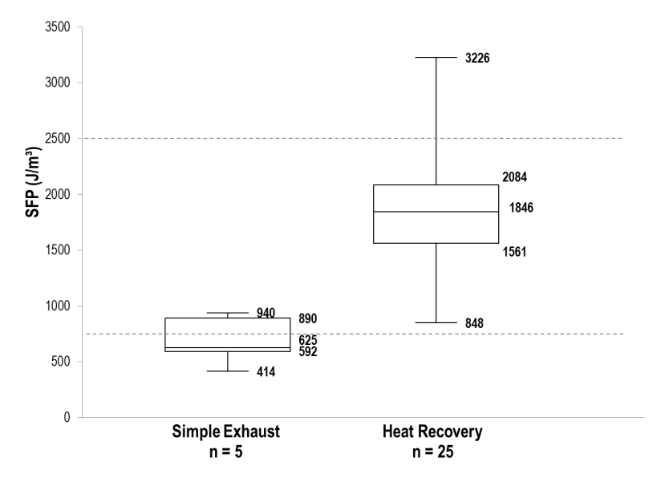
Fig. 7. measured SFP in simple exhaust and heat recovery residential ventilation systems, with default values in dashed lines.

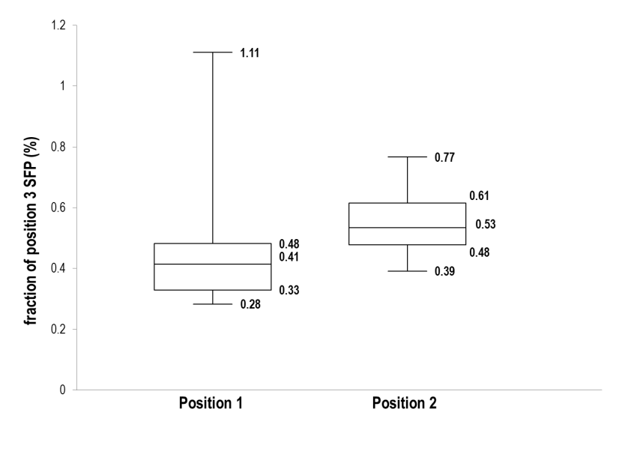
Fig. 8. measured SFP in function of control switch position in residential ventilation systems, relative to position 3 SFP (n = 22) [45]
A further note to be made in the case of mechanical exhaust ventilation directly relates to the sizing of trickle ventilators: conventional trickle sizing is thus that the total intended ventilation flow rate – the total outdoor airflow rate minus the infiltration – is far larger than the mechanically exhausted rate. The additional fraction is caused by adventitious ventilation through the trickle ventilators and should be taken into account when calculating the SFP of the system, thus reducing the lather. Based on numerical simulations with a monte carlo approach [48], the ratio of the heat loss through the mechanically exhausted flow rate to that of the total intended ventilation flow rate varies from 0.3 to 1 (Fig. 9Fig. 8) for different approaches to simple exhaust ventilations systems, with and without demand control. As is to be expected, in the demand controlled systems where the mechanical flow rate is reduced in function of the demand (Cpres reducing exhaust flow to the minimum rate except in case of presence, Crh reducing exhaust flow rate if relative humidity is low), this ratio, with a median of 0.5, is smaller than in the simple exhaust system (C), while it is higher in the system where motorized trickle ventilators are used to control the air flow without changing the fan speed, with a median of 0.95. For the demand controlled systems of the first type (Cpres, Crh), taking this effect into account will reduce the SFP by 50%, creating more favorable operating conditions for this kind of system compared to heat recovery ventilation where this kind of effect is not possible.

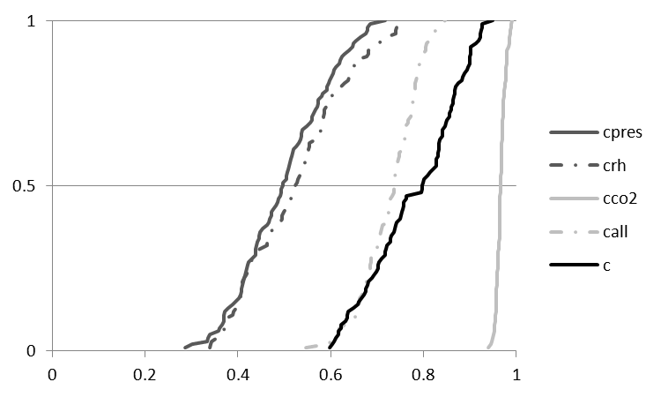
Fig. 9. cumulative distribution ratio of heat loss of mechanically exhausted flow rate to that of total intended ventilation flow rate for 1 simple (C) and 4 demand controlled (Crh, Cco₂, Cpres and Call) exhaust ventilation systems from Monte Carlo based numerical simulations.

Due to differences in the quality of implementation, specific operating conditions, control and trickle ventilator sizing, the additional electricity consumption of a heat recovery system, ΔSFP, could be considerably different from the original assumptions. The large effect of different ΔSFP on the minimal effectiveness of the heat recovery unit that allows break even operation of heat recovery ventilation, for the capitals of the 3 countries chosen as examples in table 1., is shown in table 2, using the primary energy conversion factor.

Table 1. effect of different ΔSFP on the minimal effectiveness of the heat recovery unit that allows break even operation of heat recovery ventilation for 3 typical cases in Europe.
ΔSFP (J/m³)  (% of original) | 625  (25%) | 1250  (50%) | 1875  (75%) | 2500  (100%) | 3125  (125%)
Paris  Oslo  Madrid | 0.28  0.05  0.25 | 0.56  0.10  0.50 | 0.84  0.15  0.75 | 1.12  0.20  0.99 | 1.40  0.25  1.24

It is clear that attention to pressure drop in the system during design and execution is of vital importance for net positive operation of a heat recovery system. Reducing specific fan power by 50 to 75% in reference to the default values given in the standard, which is ambitious, but, as is shown in figure 7., possible, renders heat recovery ventilation profitable in virtually the whole of Europe.

4.3 Climate
The results shown above were obtained using the Eurostat Heating Degree Day data, as explained in the methods section. Although heating degree days correlate reasonably well with the heat loss of a heated building [49], the fact that a unique reference temperature is used does not take into account the thermal quality of the building envelope, nor it’s airtightness and the effect of both on the utilization of internal and solar gains.
Furthermore, the presented results only take into account heating demand. Although the potential for heat(/cold) recovery is rather small due to the small temperature difference typical for cooling regimes in Europe, neglecting it underestimates the potential of heat recovery ventilation in the most southern regions.
The effect of using a different base temperature for the calculation of heating degree days and the inclusion of cooling degree days on the minimal effectiveness of the heat recovery unit that allows break even operation of heat recovery ventilation, for the capitals of the 3 countries chosen as examples in table 1., is shown in table 3, using the primary energy conversion factor. The heating degree days for different base temperatures and the cooling degree days were calculated from the raw data of the Eurostat heating degree day calculation, daily minimal and maximal temperature data for the same 2000-2009 period [50]. The 12.5 and 10 °C base temperatures were chosen to represent high (low energy house) and extreme (passive house) thermal quality of the building envelope respectively. The cooling degree days were calculated with a 22°C base temperature.

Table 1. effect of different base temperature for HDD and the inclusion of CDD on the minimal effectiveness of the heat recovery unit that allows break even operation of heat recovery ventilation for 3 typical cases in Europe.
Base temperature (°C) | 15 |  | 12.5 |  | 10
CDD included? | no | yes | no | yes | no | yes
Paris  Oslo  Madrid | 1.12  0.20  0.99 | 1.10  0.20  0.84 | 1.60  0.24  1.46 | 1.55  0.24  1.15 | 2.46  0.31  2.41 | 2.33  0.31  1.66

Due to the typically low number of cooling degree days, they tend to have a limited impact on the minimal HRU effectiveness while the latter is within realistic values. Note that high thermal envelope quality has a large influence on the feasibility of heat recovery ventilation in moderate climate regions like France, in contrast with popular high efficiency building concepts.
A similar effect on the minimal HRU effectiveness can be seen with the implementation of demand controlled ventilation. Demand controlled ventilation will reduce the heat loss associated with the maintenance of a certain level of indoor air quality, eg. the systems shown in figure 8. reduce the heat loss by 30 - 60% [48]. The change in minimal HRU effectiveness that this entails will depend on the decrease in average SFP that is associated with the demand control.

Conclusion
The assessment of the profitability concerning operating energy of heat recovery ventilation as opposed to simple mechanical exhaust or natural ventilation in Europe is strongly dependent on the type of conversion coefficient between electrical energy and fuel combustion for heating that is used. With primary energy, carbon dioxide emission, price and exergy, 4 broadly accepted frameworks for the comparison of these types of energy were used to calculate conversion factors for the different countries of the EU. The obtained factors showed to be sensitive to the specific energy mix and the climatic conditions of a region. This is clearly demonstrated by the cases of France and Norway, where the highest and lowest conversion factors have a ratio of 150 and 500 respectively. This huge range is attributable to nuclear respectively renewable power production on the one hand, drastically reducing the carbon dioxide factor, and the relatively small average indoor/outdoor temperature difference, allowing for high conversion factors in the exergy analysis. The results presented here demonstrate that, unless low specific fan power is achieved, for the moderate climate region of middle Europe, natural ventilation, simple exhaust mechanical ventilation and heat recovery ventilation have no clear advantage over each other as far as operating energy and associated ecologic (CO₂) and economic (Household consumer price) effects are concerned. The choice between the different systems should be made based on building specific characteristics, investment and maintenance cost. In the Mediterranean basin, heat recovery ventilation can only be operated profitably in low pressure drop and low fan power systems, while it is advantageous under virtually all tested conditions in the Scandinavian region. In contrast to low fan power, high thermal building performance tends to create unfavorable conditions for heat recovery ventilation. Overall, heat recovery ventilation can be made profitable all over Europe with regard to primary energy, carbon dioxide emissions and household consumer operating energy cost by achieving realistic best practice low specific fan power.

Acknowledgement
The authors would like to thank Eurostat, IEA, Eurogeographics and EU-JRC-Agri4cast for making their datasets public, as well as S. Caillou, of BBRI and funded by the Flemish Institute for the Promotion and Innovation by Science and Technology in Flanders, for sharing field test data.

References
[1] J. Sundell, H. Levin, W.W. Nazaroff, W.S. Cain, W.J. Fisk, D.T. Grimsrud, F. Gyntelberg, Y. Li, A.K. Persily, A.C. Pickering, J.M. Samet, J.D. Spengler, S.T. Taylor, C.J. Weschler, Ventilation rates and health: multidisciplinary review of the scientific literature, Indoor Air, 21 (3) (2011) 191-204.
[2] L. Fang, G. Clausen, P.O. Fanger, Impact of temperature and humidity on the perception of indoor air quality, Indoor Air-International Journal of Indoor Air Quality and Climate, 8 (2) (1998) 80-90.
[3] H.N. Knudsen, G. Clausen, P.O. Fanger, Sensory characterization of emissions from materials, Indoor Air-International Journal of Indoor Air Quality and Climate, 7 (2) (1997) 107-115.
[4] P.O. Fanger, Introduction of the olf and decipol unit to quantify air-pollution perceived by humans indoors and outdoors, Energy and Buildings, 12 (1) (1988) 1-6.
[5] P. Wargocki, L. Lagercrantz, T. Witterseh, J. Sundell, D.P. Wyon, P.O. Fanger, Subjective perceptions, symptom intensity and performance: a comparison of two independent studies, both changing similarly the pollution load in an office, Indoor Air, 12 (2) (2002) 74-80.
[6] U. Haverinen-Shaughnessy, D.J. Moschandreas, R.J. Shaughnessy, Association between substandard classroom ventilation rates and students’ academic achievement, 21 (2011) 121-131.
[7] I.M. Glorieux, J., Belgisch tijdsbudgetonderzoek, in, Brussels, 2008.
[8] M. Basner, K.M. Fomberstein, F.M. Razavi, S. Banks, J.H. William, R.R. Rosa, D.F. Dinges, American time use survey: Sleep time and its relationship to waking activities, Sleep, 30 (9) (2007) 1085-1095.
[9] M. Braubach, D.E. Jacobs, Environmental burden of disease associated with inadequate housing. Methods for quantifying health impacts of selected housing risks in the WHO European Region. Summary report., WHO, 2011.
[10] IPCC, Climate Change 2007, fourth assessment report, in, IPCC, Geneva, 2007.
[11] J. Bosh, F.X. Johnson, R. Mertens, N. Roubanis, P. Loesoenen, A. Gikas, J. Gorton, Panorama of Energy: Energy statistics to support EU politics and solutions, 2007.
[12] IEA, Energy Balances of OECD Countries 2008, 2008.
[13] A. Meijer, A.-J. Verkade, A.-M. Merckx, F. Duijm, G.H.t. Bolscher, The effects of improvement measures for ventilation on the indoor environment and health complaints in Vathorst, in: Clima 2010, Antalya, 2010.
[14] W. De Gids, Ventilation in Dutch houses - a study in a representative sample of the dutch housing stock, in: 24th AIVC conference: ventilation, humidity control & energy, AIVC, Washington DC, 2003.
[15] F. Durier, Trends in the French building ventilation market and drivers for changes, in: AIVC (Ed.) Ventilation Information Papers, 2008.
[16] J. Laverge, A. Janssens, Residential ventilation system optimization using monte-carlo and genetic algorithm techniques, in: IAQ 2010, ASHRAE, Kuala Lumpur, 2010, pp. 10.
[17] M. Fehrm, W. Reiners, M. Ungemach, Exhaust air heat recovery in buildings, International Journal of Refrigeration-Revue Internationale Du Froid, 25 (4) (2002) 439-449.
[18] G.V. Fracastoro, M. Serraino, Energy analyses of buildings equipped with exhaust air heat pumps (EAHP), Energy and Buildings, 42 (8) (2010) 1283-1289.
[19] D. Sakellari, P. Lundqvist, Modelling and simulation results for a domestic exhaust-air heat pump heating system, International Journal of Refrigeration-Revue Internationale Du Froid, 28 (7) (2005) 1048-1056.
[20] L. Gustavsson, A. Joelsson, Life cycle primary energy analysis of residential buildings, Energy and Buildings, 42 (2) (2010) 210-220.
[21] M. Nasif, R. Al-Waked, G. Morrison, M. Behnia, Membrane heat exchanger in HVAC energy recovery systems, systems energy analysis, Energy and Buildings, 42 (10) (2010) 1833-1840.
[22] M. Rasouli, C.J. Simonson, R.W. Besant, Applicability and optimum control strategy of energy recovery ventilators in different climatic conditions, Energy and Buildings, 42 (9) (2010) 1376-1385.
[23] Y.M. Kang, Y.J. Wang, K. Zhong, J.P. Liu, Temperature ranges of the application of air-to-air heat recovery ventilator in supermarkets in winter, China, Energy and Buildings, 42 (12) (2010) 2289-2295.
[24] K. Zhong, Y.M. Kang, Applicability of air-to-air heat recovery ventilators in China, Applied Thermal Engineering, 29 (5-6) (2009) 830-840.
[25] H.B. Hemingson, C.J. Simonson, R.W. Besant, Steady-state performance of a run-around membrane energy exchanger (RAMEE) for a range of outdoor air conditions, Int. J. Heat Mass Transf., 54 (9-10) (2011) 1814-1824.
[26] J. Liu, W. Li, J. Liu, B. Wang, Efficiency of energy recovery ventilator with various weathers and its energy saving performance in a residential apartment, Energy and Buildings, 42 (1) (2010) 43-49.
[27] Y.P. Zhou, J.Y. Wu, R.Z. Wang, Performance of energy recovery ventilator with various weathers and temperature set-points, Energy and Buildings, 39 (12) (2007) 1202-1210.
[28] M. Caciolo, P. Stabat, D. Marchio, Full scale experimental study of single-sided ventilation: Analysis of stack and wind effects, Energy and Buildings, 43 (7) (2011) 1765-1773.
[29] C. Buratti, R. Mariani, E. Moretti, Mean age of air in a naturally ventilated office: Experimental data and simulations, Energy and Buildings, 43 (8) (2011) 2021-2027.
[30] A. Dodoo, L. Gustavsson, R. Sathre, Primary energy implications of ventilation heat recovery in residential buildings, Energy and Buildings, 43 (7) (2011) 1566-1572.
[31] C. Dubrul, Inhabitant behaviour with respect to ventilation - a summary report of IEA Annex VIII, 1988.
[32] BIN, Ventilatievoorzieningen in woongebouwen, in, Brussels, 1991.
[33] ISO, Hygrothermal performance of buildings - Calculation and presentation of climatic data - Part 6: Accumulated temperature differences (degree-days), in, Geneva, 2007.
[34] Eurostat, Heating degree-days - annual data, in, 2010.
[35] Eurostat, European Regional and Urban Statistics Reference Guide, Eurostat, 2010.
[36] Eurostat, Eurostat metadata - Heating Degree Days, in: Eurostat (Ed.), Eurostat, Luxemburg.
[37] J. Laverge, A. Janssens, Evaluation of a prescriptive ventilation standard with regard to 3 different performance indicators, in: Building Simulation 2009, Proceedings, International Building Performance Simulation Association (IBPSA), 2009, pp. 859-866.
[38] J. Laverge, Comparison of the use of trickle ventilators in european residential ventilation standards, in: Roomvent 2011, Trondheim, 2011.
[39] CEN, Ventilation for non-residential builidings - performance requirements for ventilation and room-conditioning systems, in, Brussels, 2007.
[40] IEA, Energy Balances of Non-OECD Countries 2008, 2008.
[41] IEA, CO2 Emissions from Fuel Combustion (2010 Edition), in, IEA, Paris, 2010.
[42] A. Bossaer, J. Demeester, P. Wouters, B. Vandermarke, W. Vangroenweghe, Airtightness performances in new Belgian dwellings, in: 19th AIVC conference: ventilation technologies in urban areas, AIVC, Oslo, 1998, pp. 77-84.
[43] J. Remund, S. Kunz, C. Schilter, S. Müller, Meteonorm Handbook, in, Meteotest, Bern, 2010.
[44] ETH, Ecoinvent, in.
[45] S. Caillou, Optivent, in, BBRI, 2011.
[46] S. Rosseel, Optimization of concepts for demand-controlled
ventilation systems in residential buildings, Architecture and Urban Planning, Ghent University, 2008.
[47] F. van Dijken, J.R. Balvers, A.C. Boerstra, The Quality Of Mechanical Ventilation Systems In Newly Built Dutch Dwellings, in: Indoor Air 2011, Austin, 2011.
[48] J. Laverge, N. Van den Bossche, N. Heijmans, A. Janssens, Energy saving potential and repercussions on indoor air quality of demand controlled residential ventilation strategies, Building and Environment, 46 (7) (2011) 1497-1503.
[49] T. Day, Degree days: theorie and application, CIBSE, London, 2006.
[50] A.C. JRC, MARS-STAT Data Base, in, 2011.

